A

Synopsis/Project Report

On

**GEHU Administrator Portal**

Submitted in partial fulfillment of the requirement for the IV semester

**Bachelor of Technology in Computer Science and Engineering**

By

**Mohit Sanwal**

**University Roll No: 2061867**

**Under the Guidance of**

**Mr. Shashi Kumar Sharma**

**Assistant Professor**

**Dept. of CS&A**



**DEPARTMENT OF COMPUTER SCIENCE & APPLICATIONS**

**GRAPHIC ERA HILL UNIVERSITY, BHIMTAL CAMPUS**

**SATTAL ROAD, P.O. BHOWALI,**

**DISTRICT- NAINITAL-263132**

**2021 - 2022**

**STUDENT’S DECLARATION**

I, Mohit Sanwal, here by declare the work, which is being presented in the project, entitled “GEHU Administrator Portal “ in partial fulfillment of the requirement for the award of the degree **Bachelor of Technology in Computer Science and Engineering** in the session **2021-2022**, is an authentic record of my own work carried out under the supervision of Mr. Shashi Kumar Sharma.

The matter embodied in this project has not been submitted by me for the award of any other degree.

Date: 10/07/2022

(Full signature of student)

**CERTIFICATE**

**The project report entitled “GEHU Administrator Portal” being submitted by Mohit Sanwal S/o Mr. Prakash Chandra Sanwal ,enrollment no: PV-B2061867, Roll no: 2061867 to Graphic Era Hill University Bhimtal Campus for the award of bonafide work carried out by him. He has worked under my guidance and supervision and fulfilled the requirement for the submission of report.**

**(Mr. Shashi Kumar Sharma) (Dr. Ankur Singh Bisht)**

**Project Guide (HOD, CSE Dept.)**

**ACKNOWLEDGEMENT**

I take immense pleasure in thanking Honorable **“Mr. Shashi Kumar Sharma”** (**Assistant Professor,** CS&A, GEHU Bhimtal Campus) to permit me and carry out this project work with his excellent and optimistic supervision. This has all been possible due to his novel inspiration, able guidance and useful suggestions that helped me to develop as a creative researcher and complete the research work, in time.

Words are inadequate in offering my thanks to GOD for providing me everything that I need. I again want to extend thanks to our President **“Prof. (Dr.) Kamal Ghanshala”** for providing us all infrastructure and facilities to work in need without which this work could not be possible.

Many thanks to Professor **“Dr. Ankur Singh Bisht”** (HOD-CS&A, GEHU), and other faculties for their insightful comments, constructive suggestions, valuable advice, and time in reviewing this thesis.

Finally, yet importantly, I would like to express my heartiest thanks to my beloved parents, for their moral support, affection and blessings. I would also like to pay my sincere thanks to all my friends and well-wishers for their help and wishes for the successful completion of this research.

**(Mohit Sanwal)**

[**mohitsanwal2003@gmail.com**](mailto:mohitsanwal2003@gmail.com)

**ABSTRACT**

GEHU Administrator portal is a product which covers all aspects of our university. It covers every minute aspects of our institute’s work flow and integrates all processes with user friendly interface. It is an outcome of hard work done by our team. It is a rare combination of experience and precision which enables an admistrator to work everything related to the proper functioning of our university under a single portal. It streamline path of information flow in organization by taking care of following departments:

•Fee Department

•Examination Department

•Attendance

•Faculty information portal

•Student information portal

**Table Of Contents**

**Declaration I**

**Certificate II**

**Acknowledgement III**

**Abstract IV**

**Table of Contents V**

**CHAPTER1 INTRODUCTION 1**

1.1 Prologue 1

1.2 Background and Motivations 1

1.3 Purpose 1

1.4 Objectives and Scope 2

**CHAPTER 2: PROPOSED SYSTEM 3**

2.1 Front End Development 3

2.1.1 About Java…………………………………………………….3

2.2 Back End Development………………………………………….4

2.2.1 About MySQL…………………………………………………4

**CHAPTER 3: SOFTWARE AND HARDWARE REQUIREMENTS 6**

3.1 S/W and H/W requirements 6

**CHAPTER 4: DFD (Data Flow Diagram) 7**

4.1 DFD 7

**CHAPTER 5: DATABASE DESIGN 8**

5.1 Database Design 12

5.2 Table with values 16

**CHAPTER 6:** **ER DIAGRAM 17**

6.1 ER diagram 17

6.2 Schema Diagram 18

**CHAPTER 7: CODING OF FUNCTION 19**

**CHAPTER 8:** **TESTING STRATEGIES 25**

**CHAPTER 9: LIMITATIONS…………………………………………………27**

**CHAPTER 10: SNAPSHOTS …………………………………………………..28**

**CHAPTER 11: CONCLUSION…………………………………………………32**

**REFERENCES 33**

# **CHAPTER1 INTRODUCTION**

# **Prologue**

Our team has focused on building a portal which does all the jobs of a university, from teacher to student, so that both time and effort is saved. This Project is built on JAVA programming language with swing so that the admin or user can fetch or insert data with a good ease due to the powerful GUI interface which allows admin to execute multiple tables at a time of a database. It contains all details of a student and teacher like their attendance, their updation etc and also contains some utilities like notepad ,calculator and web browser in just a single click away from the admin. In short,it is a combination of many portals into one which makes it very to administrate a university.

# **Background and Motivations**

It was our dream that we can do something for our university,though it is a very small beginning but as a quote says,”one may walk over a mountain one step at a time”,so with this motivation in mind we have made this GEHU Administrator Portal. One main reason is also that there are lots of softwares and portals available to maintain list of students and faculties but they are made for a specific task , but as we mentioned in the prologue we have made this portal abstractly dedicated to universities and it serves its purpose there.

# **Purpose**

• Drive operational efficiency.

• Self-service systems with simple to use with little or no training.

• Elimination of duplicate data entry processes.

• Integrated with Online Application workflow with unified data model.

• Monitoring and decision support system.

• Automation of all the Academic / Examination / Administration operations.

• Ease and accuracy of reporting.

# **Objectives and Scope**

This project deals with the various functioning in College management process. The main idea is to implement a proper process to system. In our existing system contains a many operations registration, student search, fees, attendance, exam records, performance of the student etc. All these activity takeout manually by administrator.

**CHAPTER 2:** **PROPOSED SYSTEM**

# **Front End Development:**

An important issue for the development of a project is the selection of suitable front- end and back-end. When we decided to develop the project we went through an extensive study to determine the most suitable platform that suits the needs of the organization as well as helps in development of the project.

The aspects of our study included the following factors. Front-end selection:

1. It must have a graphical user interface that assists employees that are not from IT background.

2. Scalability and extensibility.

3. Flexibility.

4. Robustness.

5. According to the organization requirement and the culture.

6. Must provide excellent reporting features with good printing support.

7. Platform independent.

8. Easy to debug and maintain.

9. Event driven programming facility.

10. Front end must support some popular back end like MySQL.

According to the above stated features we selected PHP and CSS as the front-end for developing.

# **2.1.1** **About Java:**

Java is a general-purpose, class-based, object-oriented programming language designed for having lesser implementation dependencies. It is a computing platform for application development. Java is fast, secure, and reliable, therefore. It is widely used for developing Java applications in laptops, data centers, game consoles, scientific supercomputers, cell phones, etc.

Here are some important Java applications:

• It is used for developing Android Apps

• Helps you to create Enterprise Software

• Wide range of Mobile java Applications

• Scientific Computing Applications

• Use for Big Data Analytics

• Java Programming of Hardware devices

• Used for Server-Side Technologies like Apache, JBoss, GlassFish, etc.

# **Back End Development**

Back End Selection:

1. Multiple user support.

2. Efficient data handling.

3. Provide inherent features for security.

4. Efficient data retrieval and maintenance.

5. Stored procedures.

6. Popularity.

7. Operating System compatible.

8. Easy to install.

9. Various drivers must be available.

10. Easy to implant with the Front-end.

According to above stated features we selected MySQL as the backend.The technical feasibility is frequently the most difficult area encountered at this stage. It is essential that the process of analysis and definition be conducted in parallel with an assessment to technical feasibility. It centers on the existing computer system (hardware, software etc.) and to what extent it can support the proposed system.

# **2.2.1** **About SQL:**

SQL is Structured Query Language, which is a computer language for storing, manipulating and retrieving data stored in a relational database.

SQL is the standard language for Relational Database System. All the Relational Database Management Systems (RDMS) like MySQL, MS Access, Oracle, Sybase, Informix, Postgres and SQL Server use SQL as their standard database language.

MySQL is a fast, easy-to-use RDBMS being used for many small and big businesses. MySQL is developed, marketed and supported by MySQL AB, which is a Swedish company. MySQL is becoming so popular because of many good reasons.[1]

MySQL is released under an open-source license. So you have nothing to pay to use it. MySQL is a very powerful program in its own right. It handles a large subset of the functionality of the most expensive and powerful database packages. MySQL uses a standard form of the well-known SQL data language. MySQL works on many operating systems and with many languages including PHP, PERL, C, C++, JAVA, etc.

MySQL works very quickly and works well even with large data sets. MySQL is very friendly to PHP, the most appreciated language for web development. MySQL supports large databases, up to 50 million rows or more in a table. The default file size limit for a table is 4GB, but you can increase this (if your operating system can handle it) to a theoretical limit of 8 million terabytes (TB).

Also, they are using different dialects, such as −

• Oracle using PL/SQL,.

• SQL is widely popular because it offers the following advantages −

• Allows users to access data in the database management systems.

• Allows users to describe the data.relational

• Allows users to define the data in a database and manipulate that data.

• Allows to embed within other languages using SQL modules, libraries & pre-compilers

.• Allows users to create and drop databases and tables

.• Allows users to create view, stored procedure, functions in a database

.• Allows users to set permissions on tables, procedures and views.

**CHAPTER 3:**   **SOFTWARE AND HARDWARE**

**REQUIREMENTS**

# **Hardware Requirements :**

Processor Brand : Intel

Processor Type : Core i3

Processor Speed : 2 GHz

Processor Count : 1

RAM Size : 2 GB

Memory Technology : DDR3

Computer Memory Type : DDR3 SDRAM

Hard Drive Size : 160 GB

# **Software Requirements :**

Operating system : Windows 10

Application server : JAVA (NetBeans)

Front end : JAVA

Connectivity : JDBC Driver

Database connectivity : WAMP (MYSQL Console)

**CHAPTER 4:** **DFD (Data Flow Diagram)**

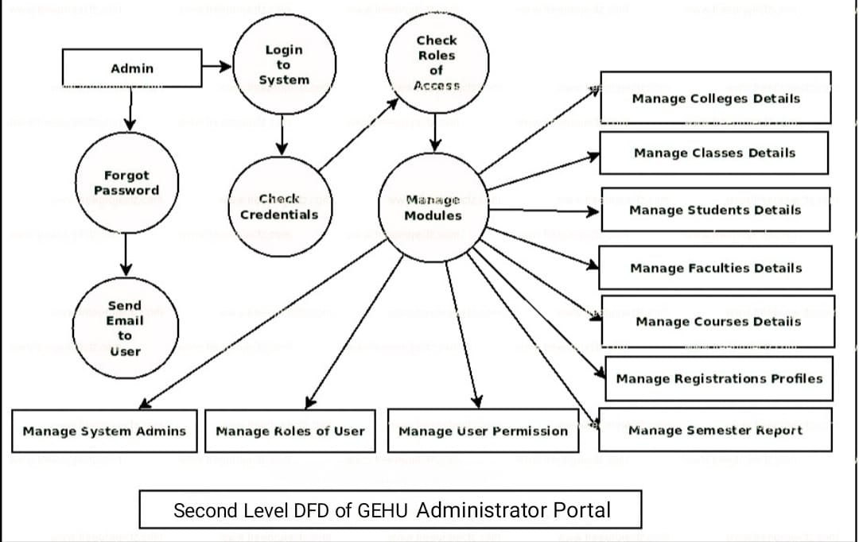

**CHAPTER 5:** **DATABASE DESIGN**

**LOGIN TABLE**

Account Table: Account table consists of attributes which are Username and Password, .

Desc login;

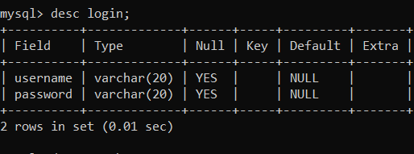

Fig 5.1 login table description

**STUDENT TABLE**

Student table :Student table is used to add the details of new student like Name,phoneno.,DoB,course,Branch etc..

Desc student;

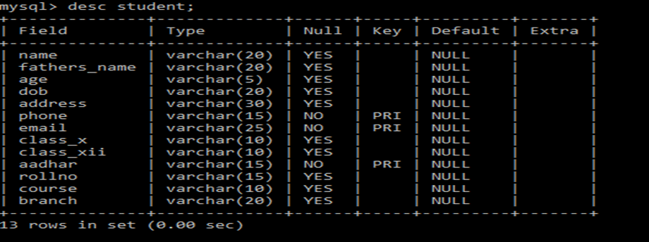

Fig 5.2 Student table description.

# **TEACHER TABLE**

Teacher table: Teacher table is used to add the details of new student like Name, phoneno.,DoB, course,Branch etc..

Desc teacher;

# 

# Fig 5.3 Teacher table description

# **ATTENDANCE_STUDENT TABLE**

Attendance_Student Table: Attendance_Student table is used to mark the attendance of the student day to day which as attributes like rollno,name,first and second half.

Desc attendance_student;

# 

Fig 5.4 Attendance_Student table description.

# 

# **ATTENDANCE_TEACHER TABLE**

Attendance_Teachertable :Attendance_Teacher table is used to mark the attendance of the teacher day to day which as attributes like emp_id,name,first and second half.

Desc attendance_teacher; 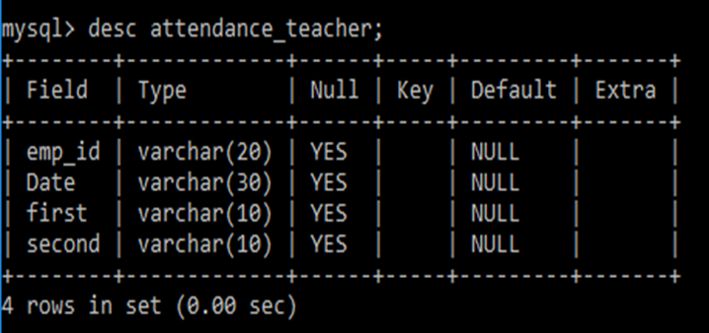

Fig 5.5 Attendance_Teacher table description.

# **SUBJECT TABLE**

Subject table :Subject table is used to add the subjects of the student in that particular sem with the attributes like rollno and five subjects.

Desc Subject;

# 

# Fig 5.6 Subject table description.

# 

# **MARKS TABLE**

# Marks table :Marks table is used to add the marks of the particular subjects of the student in a particular sem and the attributes used are rollno and five subject marks.

# Desc Marks;

# 

# Fig 5.7 Marks table description.

# **FEE TABLE**

# Fee table:fee table is used to pay the fee dues of the student for that particular sem and the attributes used like rollno, name, fathersname, course, branch, sem and fee_paid.

# Desc Fee;

# 

# Fig 5.8 Fee table description.

# 

# **TABLE WITH VALUES**

# **Output design:**

# **login table :**login table consists of attributes which will be retrived from user when the user signsup/logs in.

# Select * from account;

# 

# Table 1.1 login table

# **Student table**: Student table is used to add the details of new student like Name,phoneno.,DoB,course,Branch etc..

# Select * from student;

# Table 1.2 Student table

# 

# **Teacher table :**Teacher table is used to add the details of new student like Name,phoneno.,DoB,course,Branch etc..

# Select * from teacher;

# 

# Table 1.3 Teacher table

# **Attendance_Student table** :Attendance_Student table is used to mark the attendance of the student day to day which as attributes like rollno,name,first and second half.

# Select * from attendance_student;

# 

# Table 1.4 Attendance_student table

# 

# **Attendance_Teacher table** :Attendance_Teachertable is used to mark the attendance of the teacher day to day which as attributes like emp_id,name,first and second half.

# Select * from attendance_teacher;

# 

# Table 1.5 Attendance_teacher table

# Subject table : Subject table is used to add the subjects of the student in that particular sem with the attributes like rollno and five subjects.

# Select * from Subject;

# 

# Table 1.6 Subject table

# 

# **Marks table :**Markstable is used to add the marks of the particular subjects of the student in a particular sem and the attributes used are rollno and five subject marks.

# Select * from Marks;

# 

# Table 1.7 Marks table

# Fee table :fee table is used to pay the fee dues of the student for that particular sem and the attributes used like rollno, name, fathersname, course, branch, sem and fee_paid.

# Select * from Fee;

# 

# Table 1.8 Fee table

**CHAPTER 6: ER DIAGRAM**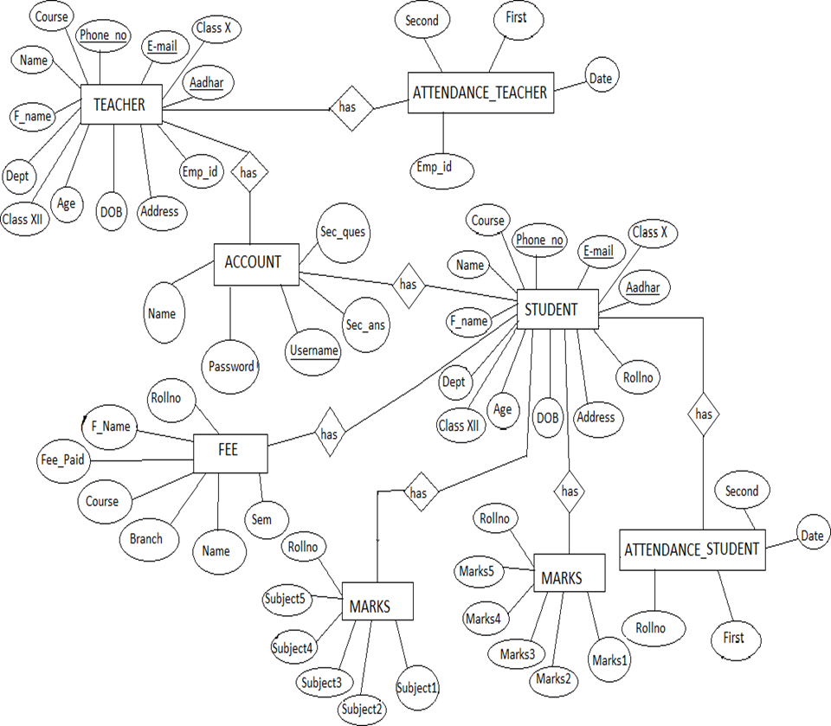

ER Diagram is a high-level conceptual data model diagram. Entity-Relation model is based on the notion of real-world entities and the relationship between them. ER modelling helps you to analyse data requirements systematically to produce a well-designed database.

# **SCHEMA DIAGRAM:**

# Schema diagram A schema diagram is the skeleton structure that represents the logical view of the entire database. It contains a descriptive detail of the database.

# 

# Figure 4.2: Schema Diagram for GEHU Administrator Portal

## CHAPTER 7: CODING OF FUNCTIONS

We have made different classes for our portal, each class has its own unique importance ,some of them are discussed below:

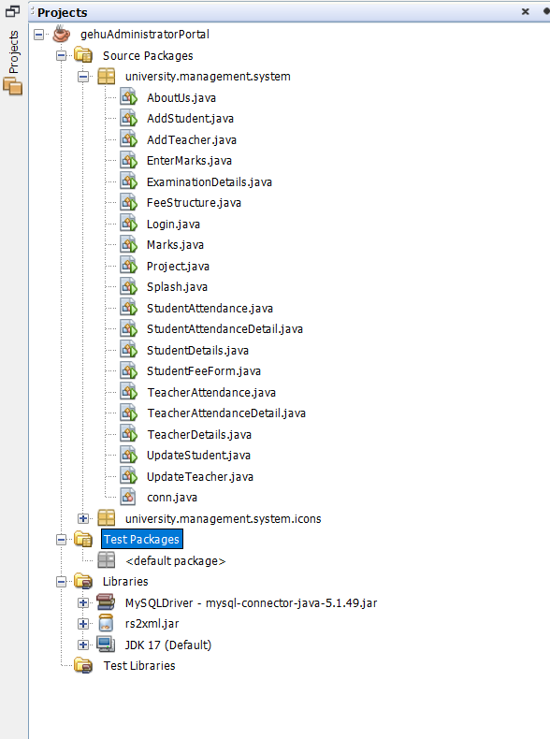

Fig1:All Classes

1. **Connection class**

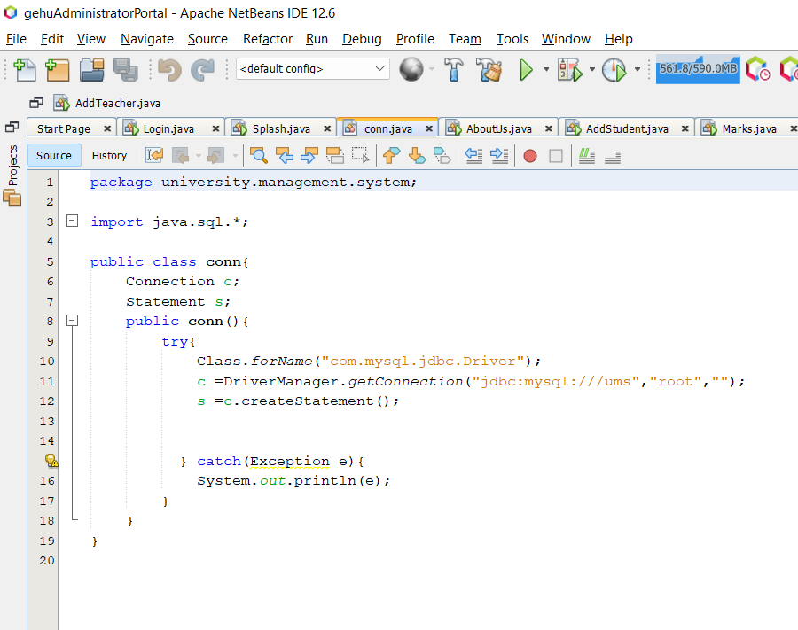

Fig 2: connection class

# **Splash class**

Fig 3:Splash class

1. 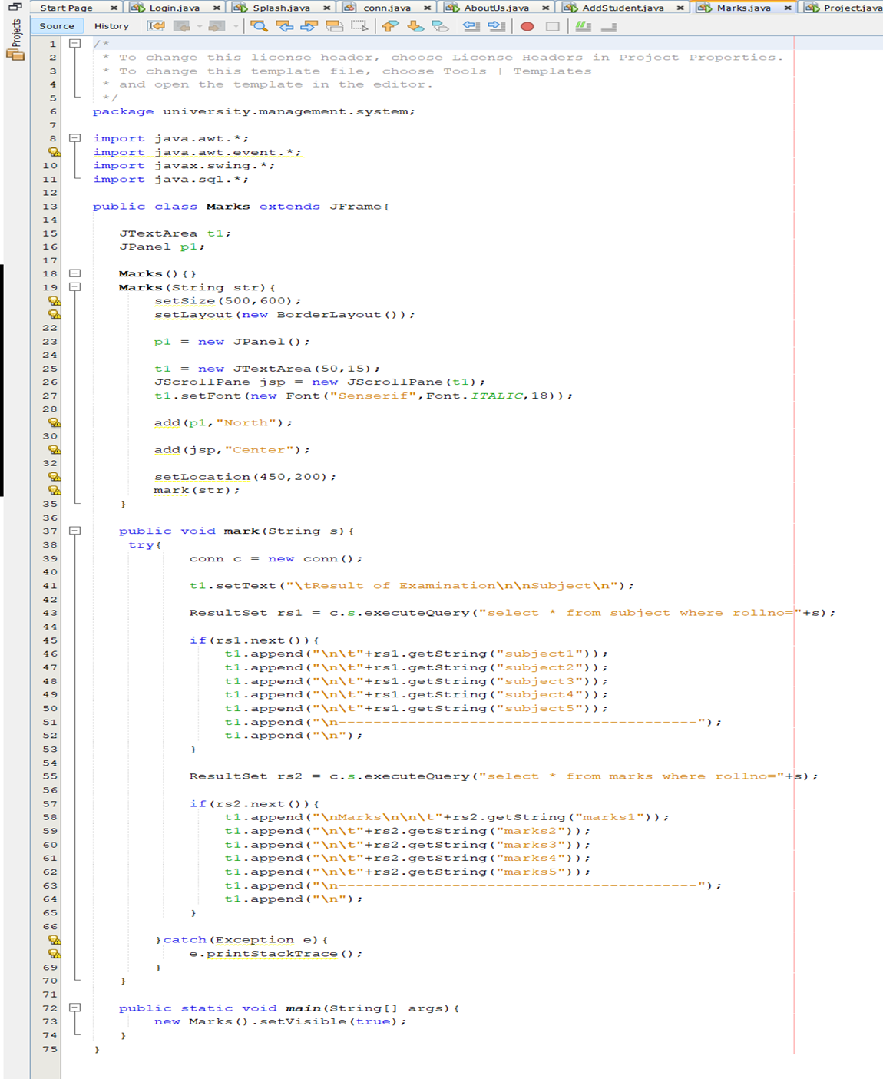**Marks Class**

Fig 4:Marks Class

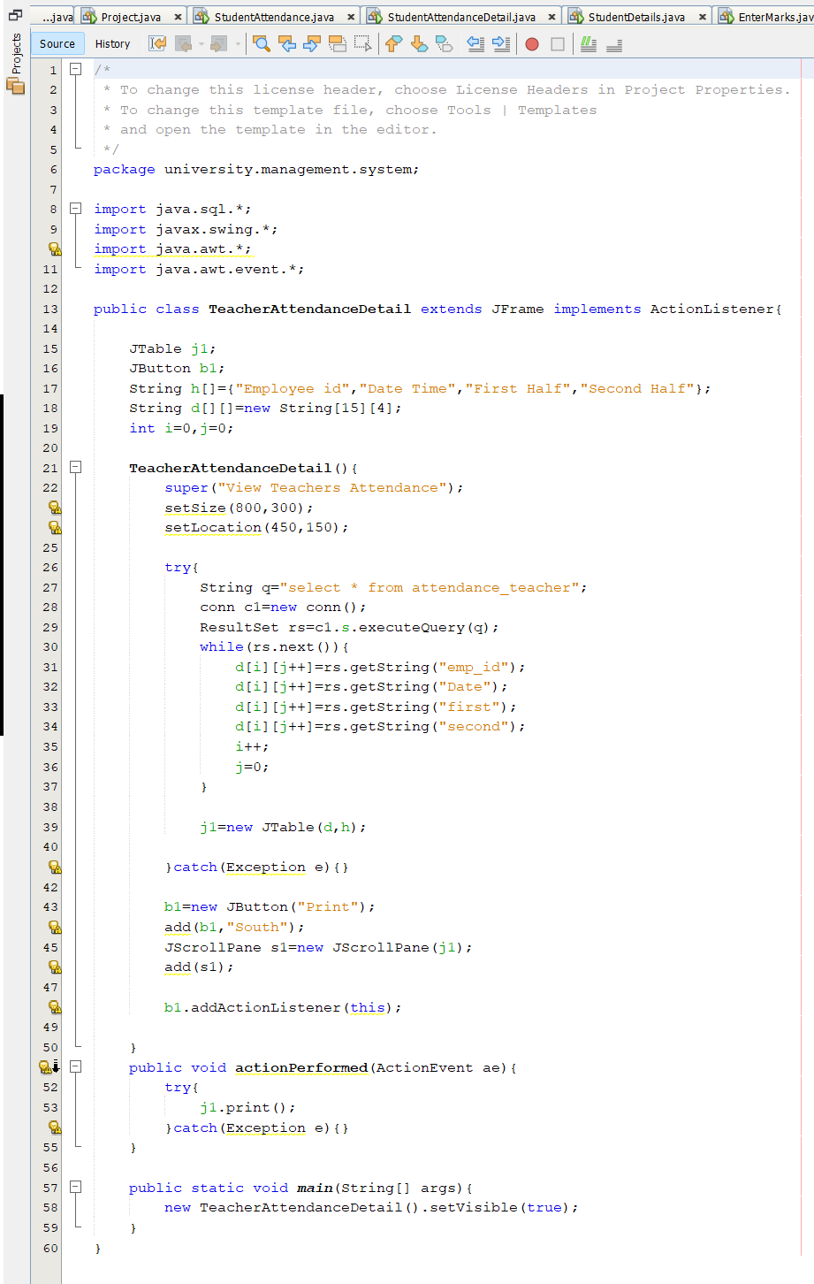**4.Teacher Attendance Detail Class**

Fig5:Teacher Attendance Detail Class

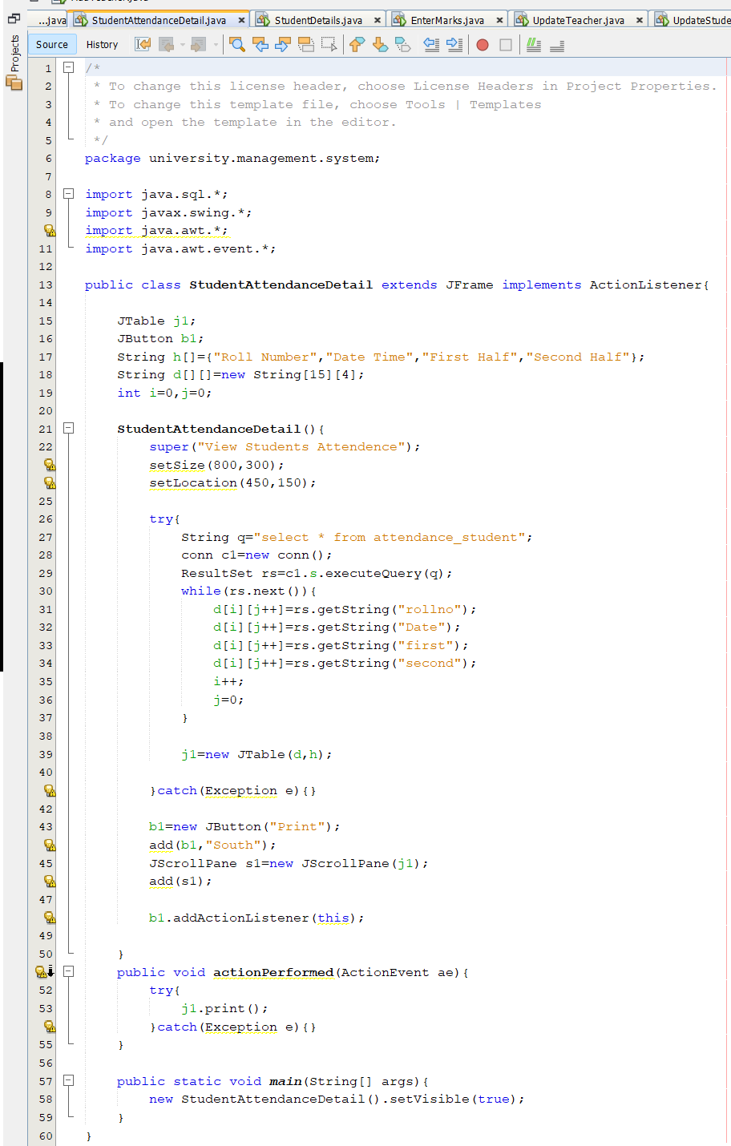**5.Student Attendance Detail Class**

Fig 6: Student Attendance Detail Class

## CHAPTER 8 TESTING STRATEGIES

# **TESTING**

# System testing is the stage of implementation, which is aimed at ensuring that the system works accurately and efficiently before live operation commences. Testing is the process of executing the program with the intent of finding errors and missing operations and also a complete verification to determine whether the objectives are met and the user requirements are satisfied. The ultimate aim is quality assurance.

# **Unit Testing**

# The software units in a system are modules and routines that are assembled and integrated to perform a specific function. Unit testing focuses first on modules, independently of one another, to locate errors. This enables, to detect errors in coding and logic that are contained within each module. This testing includes entering data and ascertaining if the value matches to the type and size supported by java. The various controls are tested to ensure that each performs its action as required.

# **Integration Testing**

# Data can be lost across any interface, one module can have an adverse effect on another, sub functions when combined, may not produce the desired major functions. Integration testing is a systematic testing to discover errors associated within the interface. The objective is to take unit tested modules and build a program structure. All the modules are combined and tested as a whole. Here the Server module and Client module options are integrated and tested. This testing provides the assurance that the application is well integrated functional unit with smooth transition of data.

# 8.3 User Acceptance

# Testing User acceptance of a system is the key factor for the success of any system. The system under consideration is tested for user acceptance by constantly keeping in touch with the system users at time of developing and making changes whenever required.

## 

## CHAPTER 9 LIMITATIONS

Hardware and Software Limitations:

1. The minimum hardware requirement for running the project smoothly in any system is 2GB RAM and 1GB Free hard disk space.
2. User should have operating system not below windows 7.
3. Both WAMP server and netbeans should be perfectly installed in the system.

# **CHAPTER 10 SNAPSHOTS:**

**1.Welcome Page**: This page represents the first thing about our website. It leads on to the login point for its personnel.

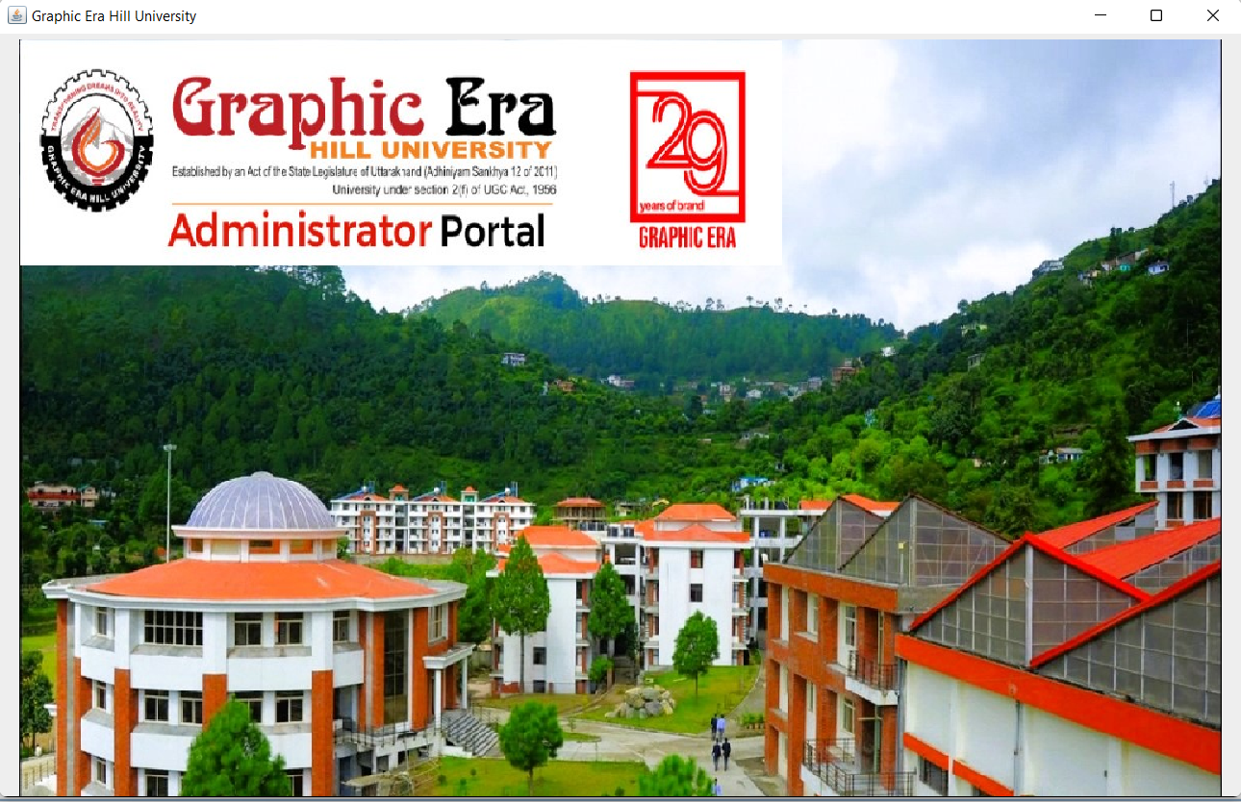

Figure 1 : welcome page

**2.Login page**: This page represents logging in. It leads to username and password from the admin for security reasons. These information are mandatory.

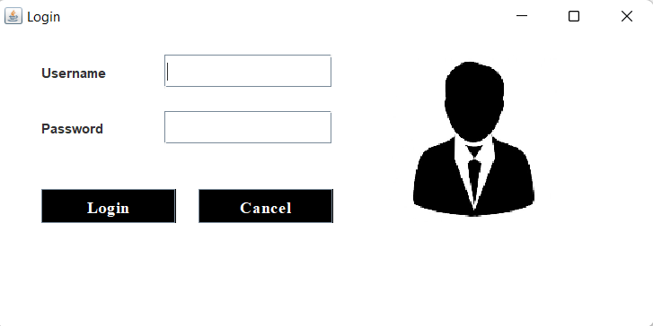

Figure 2: login page

**3. Home page user :** This page shows us what user can see and access. He can add, remove,update and upload the data. He can logout from the website in homepage.

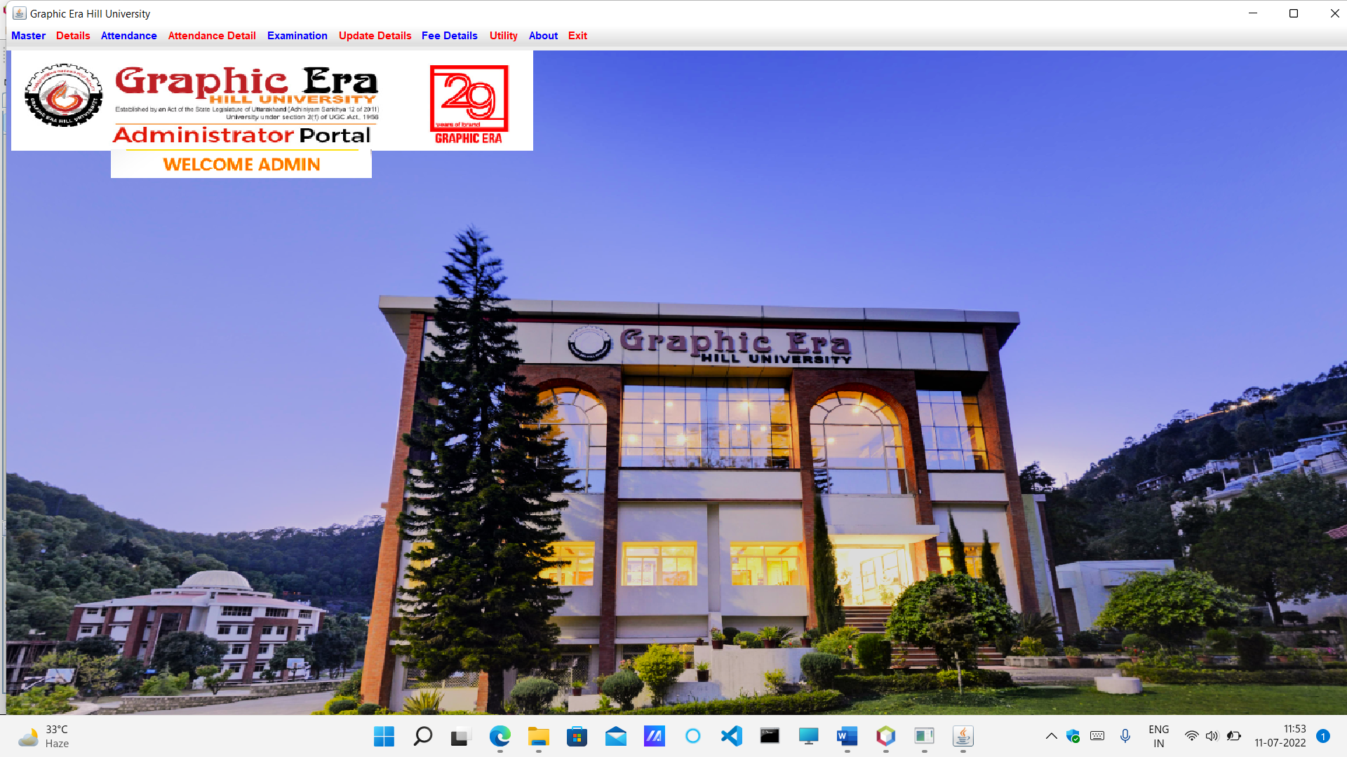

Figure 3: Home page user

**4. Student form :** In this we can add the new student details which will be stored in back end of user.This details further can updated in the update page.

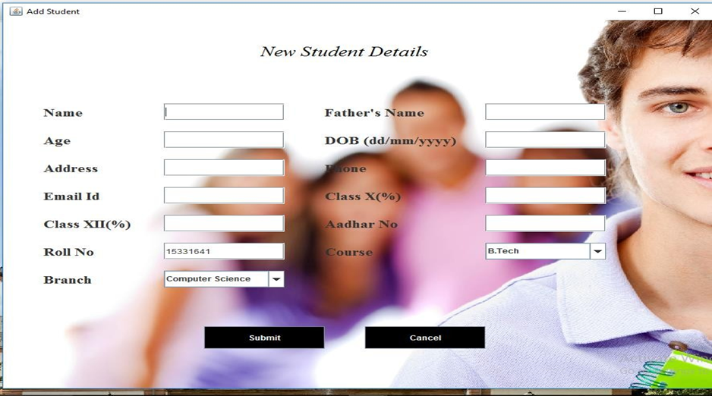

Figure 4: Student form

**5. Teacher form:** In this we can add the new teacher details which will be stored in back end of user.This details further can updated in the update page.

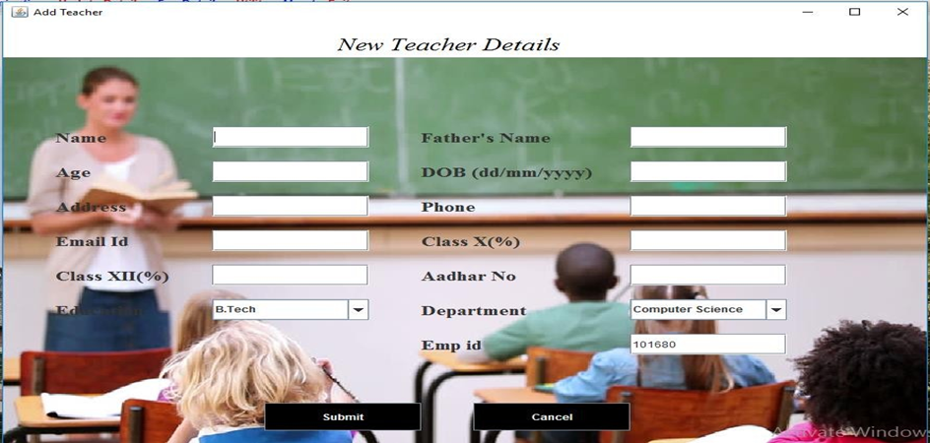

Figure 5: Teacher form

**6. Marks and Subject page :** In this page we can enter the subjects and marks scored in that particular subject along the rollno.

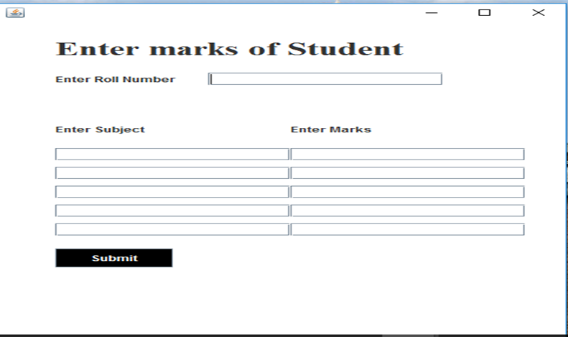

Figure 6: Marks and Subject page

**7. Fee payment page** : In this page we can the pay the fee dues of the particular student which uses rollno,course,branch and sem to pay the fee.

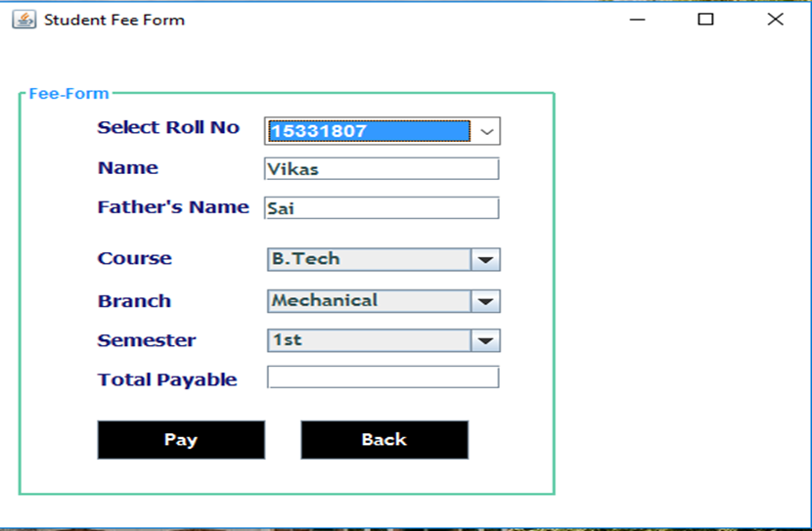

Figure 7: Fee payment page

## CHAPTER 11 CONCLUSION:

# The project entitled as GEHU Administrator Portal is the system that deals with the issues related to any particular institution.

# This project is successfully implemented with all the features mentioned in system requirements specification.

# The application provides appropriate information to users according to the chosen service.

# The project is designed keeping in view the day to day problems faced by a college.

# Deployment of our application will certainly help the college to reduce unnecessary wastage of time in personally going to each department for some information.

# Awareness and right information about any college is essential for both the development of student as well as faculty. So this serves the right purpose in achieving the desired requirements of both the communities. Hence,I hope that this synopsis had helped you understand the functioning and use of our project. **REFERENCES**

Books and Websites:

• Internet & World Wide Web: How to Program Deitel, PJ Deitel.

• Code for Interview YouTube Channel.

• Database System Concepts, by Silberschatz, Sudarshan, and Korth.

• Fundamentals of Database Systems, RamezElmasri and Shamkant B. Navathe, 7th Edition. 2017, Pearson...

 • Informatics Practices, Sumita Arora